CHILD LABOUR
No one will produce what no one buys….
Child Labour continues to be a concern in this day and age but because of the efforts of labour groups, governments, companies and ordinary people like you and me, the number of companies employing child labour is going down.
What can be done to stop child labour completely? How can we as a civilization come together and solve this injustice being done to our young generation? There are many ways to help and every action that discourages this inhuman practice, no matter how small, will go a long way.
Using your consumer power
Social media guarantees that consumers nowadays have very powerful voices. Negative consumer feedback and campaigns, bad publicity – companies avoid all this. Not one organization wants to be accused of employing child labour as this will affect their profitability when consumers boycott their products.
As a consumer, you can make sure that the products you’re buying does not employ child labour. If you’re not sure how a product was produced you can do some research. Just simply being aware of the latest news and efforts on the child labour industry can give you the information you need to make responsible choices. There are many websites that give information on which companies/brands are being accused of child labour practices.
There are also sites like “Firmhugger” where you can find a list of green products and ethical companies. The list is updated by the consumers themselves. You can patronize these products to support companies who are making a positive move to make our world a better place.
If there’s no market for the products being made by children, there won’t be any point producing them. If you’re wondering how to stop child labour the answer is simple – Stop Buying Their Products.
Always remember that the consumers are the driving force of global economies. You can help drive it in the right direction – away from Child Labour practices. As an individual, you can raise awareness, question the stores about who makes their product, demand labelling and transparency and support products that are not violating the rules of Fair Trade.
Passion can drive change!
If you’re really passionate about it and would like to join a group, find a local group, union or even start your own. Raising awareness and educating people on why child labour needs to be stopped is one of the best ways to end this practice. People need to know that it’s happening, where, how and why.
There are more than 200 million children worldwide who are still doing hazardous work – work that are not meant to be done by their small hands. Companies utilize child labour because they’re cheap and it raises their profit margins. Greed is the reason and you can stop it. If they want their products to be bought then they should stop using children to make them – or you won’t buy it. That’s the kind of power you have.
http://www.theworldcounts.com/stories/How-to-Stop-Child-Labour
Child labour in sweatshops exist to this day and there are millions of workers who are grossly underpaid, working in less than acceptable conditions – and majority of them are children.
What are Sweatshops?
A sweatshop is defined by the Department of Labour as a factory which violates 2 or more labour laws. It has 3 characteristics – low pay, long brutal hours and unhealthy working conditions. An adult who has no other option but to work in a sweatshop is in a pitiful situation indeed, but more so when a child is sold or forced to work in such an environment.
Although the number of children in child labour has declined in recent years, 1 in 6 children between the ages of 5 to 14 years old are still in some form of child labour in developing countries.
Sweatshops like employing children since they seldom complain about the working conditions and they are given a smaller wage. Rugs and Carpet manufacturers prefer children because of their small and fast hands. Child slavery is rampant in the Cocoa industry.
Some of the largest clothing brands linked to sweatshops are Walmart, Nike, Hanes, Benetton, Adidas and Gap.
Defenders of sweatshops reason out that “Something is Better than Nothing”
Is this the truth? Is this what our society has become? Our needs and demands are great but is it justifiable to enslave people so we can get what we want?
How can we help change this thinking? How can we force corporations to give more priorities to their workers?
We don’t believe that something is better than nothing. We all need to be treated humanely even when our need is great. Fortunately, many companies are waking up and mending their ways.
Choose Fair Trade Products and buy from Ethical Companies. Practice your buying power and DO NOT buy products that are known to come from sweatshops.
http://www.theworldcounts.com/stories/Child-Labour-in-Sweatshops
WHAT CAN YOU DO?
AS A CONSUMER
As a consumer you have a powerful voice. Companies do not want to be associated with child labour and are sensitive to bad publicity and consumer campaigns. Many products have been made with child labour. This is not always easy to trace, but we can try to pay as much attention as possible and take this into consideration when buying articles.
As long as there is a market for products made by children it is difficult to eliminate child labour. As a consumer, you can help right here in Europe to protect and expand the Child Labour Free Zones. For instance, by making sure that what you buy has not been made by children. If you are not sure where a product comes from or how it was produced, just ask! The more people working against child labour, the more Child Labour Free Zones will be created worldwide. Unfortunately, there is no common label to indicate that a product is "guaranteed as not having been made with child labour". However, there are organisations that work towards introducing this label in cooperation with business, such as those in the food and clothing sectors.
AS A COMPANY OR ORGANISATION
International trade and investments afford opportunities and open new markets. When doing business across borders it is important for companies to do so in a socially responsible manner: with care for people, resources, the environment and the immediate surroundings. As an entrepreneur you can play a positive and visible role and take responsibility by making a lasting influence and doing what you can, for instance towards the elimination of child labour.
AS A POLITICIAN
Where best to start the fight against child labour? With employers who allow children to work in their factories? With importers who buy the products from the factories as cheaply as possible? With shopkeepers and customers who are not critical about what they buy?
AT SCHOOL
Education in the Netherlands can play an important role in fighting child labour. Awareness can be raised and action taken at every level of the education system. Many teachers, pupils and other colleagues in education have shown that this is not difficult. Their success stories and tips have been compiled in the special publication "Let’s all go to school", along with other suggestions for activities at school and in class.
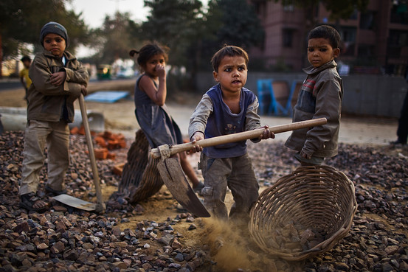
http://stopkinderarbeid.nl/Stop-Childlabour/What-you-can-do
http://www.stopkinderarbeid.nl/Stop-Childlabour/What-you-can-do/As-a-consumer
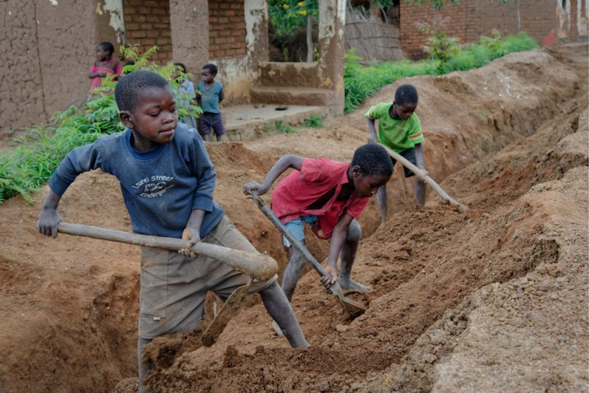

UNITING TO END CHILD LABOUR: KEEP THE PINWHEEL MOVING!

Young people around the world are uniting with creativity, strength and determination to make a stand against child labour. The pinwheel has become the symbol of the fight against child labour, and the movement of the pinwheel itself is the message we want to convey. The five blades of the pinwheel represent the different continents of the world and the wind that makes the pinwheel spin is the will to act and to pass on the message until all countries take adequate measures to end child labour.
The pinwheel campaign began in Brazil, with the National March for the Eradication of Child Labour in 2004. Former working children and adolescents elaborated a Term of Agreement to eradicate child labour which was presented to all Brazilian states and to the Federal District by children who travelled to hand it to the next neighbouring state.
Now the pinwheel campaign has gone worldwide! It is used at events to raise awareness on child labour all year round and in particular on the World Day Against Child Labour on 12 June. On 12 June 2009, in Geneva, hundreds of children from local schools gathered at the Place des Nations in front of the United Nations building to show their solidarity with other children who have to work instead of going to school. They made pinwheels in the spirit of “pass it on” and they signed a petition calling on all Member States of the United Nations to end child labour.
“By participating in this World Day, we, children in Geneva, symbolically representing all the children of the world, celebrate the 10th anniversary of Convention No. 182 against the worst forms of child labour…
…By our presence today, we demonstrate our support for these children, and we call for equal rights, dignity and respect for everyone - both girls and boys – in all countries.”
Other countries will follow these initiatives, and the pinwheel campaign will travel from state to state and from country to country. Get involved in your country! Be creative! Motivate your school and your community to join you in taking action!
http://www.ilo.org/ipec/Campaignandadvocacy/Youthinaction/Pinwheel/lang--en/index.htm
FNs KONVENSJON OM BARNETS RETTIGHETER (BARNEKONVENSJONEN)
Barn har behov for spesiell beskyttelse, derfor har de sine egne rettigheter uttrykt i barnekonvensjonen. Den gir barna de samme grunnleggende rettigheter, uansett hvem de er og hvor de bor. Rettighetene er politiske, økonomiske, sosiale og kulturelle og gjelder alle under 18 år, uavhengig av nasjonalitet, kjønn, sosial status, religion, kultur. Konvensjonen bygger på prinsippet om at barnets beste alltid skal komme først i alle situasjoner, over alt.
Barnekonvensjonen krever at medlemslandene anerkjenner og respekterer barns grunnleggende rettigheter til liv, utvikling, beskyttelse og deltagelse. Det er staten som har ansvaret for at barns rettigheter blir fulgt.
Konvensjonen ble utformet av FNs menneskerettighetskommisjon, og er basert på FNs erklæring om barnets rettigheter, som ble vedtatt 30 år tidligere. Barnekonvensjonen trådde i kraft året etter at det ble vedtatt, etter at 20 land hadde endelig godkjent vilkårene i avtalen. Gjennomføringen av konvensjonen overvåkes av FNs barnekomité, som jevnlig evaluerer tilstanden i de enkelte medlemslandene og kommer med anbefalinger og observasjoner. Konvensjonen er svært omfattende, og dekker de fleste aspekter innenfor barns rettigheter til liv, utvikling, beskyttelse og deltagelse.
Gjennomføring
Barnekonvensjonen er en av de mest omfattende menneskerettighetskonvensjonene fremforhandlet i regi av FN. Dette er både avtalens styrke og dens svakhet: Det omfattende vernet gjør medlemskap i konvensjonen særlig betydningsfullt, men dette svekkes av at en lang rekke stater har fått anledning til å reservere seg mot større deler av innholdet.
Reservasjonene tydeliggjør hvor problematisk det kan være å vedta ved lov hva som skal være den beste formen for barndom – ”barnets beste” går som en rød tråd gjennom alle artiklene i konvensjonen, og det er på ingen måte universelt anerkjent at barn i det hele tatt kan ha egne rettigheter.
Frem til konvensjonen ble vedtatt var barns rettslige status i en rekke land først og fremst knyttet opp mot foreldrenes, og deres rett til å bestemme over barna. Barnekonvensjonen kan ses som et forsøk på å oppnå allmenn anerkjennelse av at også barn er selvstendige individer, med særskilte behov og rettigheter.
ALLE BARN ER LIKE!
http://www.fn.no/Bibliotek/Avtaler/Menneskerettigheter/FNs-konvensjon-om-barnets-rettigheter-Barnekonvensjonen
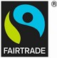
WHAT FAIRTRADE DOES
Fairtrade is about better prices, decent working conditions and fair terms of trade for farmers and workers. It’s about supporting the development of thriving farming and worker communities that have more control over their futures and protecting the environment in which they live and work. And it’s your opportunity to connect with the people who grow the produce that we all depend on.
What does the FAIRTRADE Mark mean?
When you buy products with the FAIRTRADE Mark, you support farmers and workers as they work to improve their lives and their communities. The Mark means that the Fairtrade ingredients in the product have been produced by small-scale farmer organisations or plantations that meet Fairtrade social, economic and environmental standards. The standards include protection of workers’ rights and the environment, payment of the Fairtrade Minimum Price and an additional Fairtrade Premium to invest in business or community projects.
Fairtrade works to benefit small-scale farmers and workers, who are amongst the most marginalised groups globally, through trade rather than aid to enable them to maintain their livelihoods and reach their potential.
For certain products, such as coffee, cocoa, cotton and rice, Fairtrade only certifies small-scale farmer organisations. Working through democratic organisations of small-scale farmers, Fairtrade offers rural families the stability of income which enables them to plan for the future.
For some products such as bananas, tea and flowers, Fairtrade also certifies plantations - companies that employ large numbers of workers on estates. Our Standards for such large-scale production units differ and protect workers’ basic rights; from keeping them safe and healthy, allowing them freedom of association and collective bargaining, to preventing discrimination and ensuring no bonded or illegal child labour. They also require employers to pay wages that progress towards living wage benchmarks. Ensuring decent working conditions and strong worker rights is central to Fairtrade’s work.
The producers themselves decide how the Fairtrade Premium should be invested. The premium is the additional sum of money paid on top of the Fairtrade minimum price that farmers and workers receive which can be invested in social, environmental and economic developmental projects to improve their businesses and their communities. In real terms, it means investment in schools, transport, health care, sanitation, an improved environment and better business equipment and practices.
http://www.fairtrade.org.uk/en/what-is-fairtrade/what-fairtrade-does

