Task 1
The magazine looked fresh and clean, also readable in a Microsoft Word format. The texts were good written and the subtitles fit very well under the subject.
The magazine it is pretty much perfect in my eyes. But of course, a magazine should be formatted as a magazine. You know pictures on the left or right side, and some texts under. Not a big picture and a bunch of text under. But to the end, it was better than good, it was perfect.

Task 2
From homeless to Harvard
The text, “From homeless to Harvard”, explains the street life in detail and what is takes to get out of the street. It is about this girl named Khadijah Williams. In this example, Khadijah worked and studied hard.

I think there lays the problem. If you are adult, it is nobody than you who can end the problems. You have to take full responsibility for your life, because nobody else will do it. If you begin to do drugs because you are so unhappy with your life, that’s okay. But if you are not taking responsibility for your actions, and expecting someone else, or sociality to take care of you, then you are dead wrong.

Remember, beauty is only skin deep

What is real beauty? Why is there so many people, complain and criticize, their own and others beauty? Let me ask you again, what is beauty?
That question, we’ll review, explore and explain today.

Let me start; is your beauty, equal to others? Are you happy with your beauty? Many people are not. Why not? The sociality has done beauty to something superficial, beauty is more than power and money, beauty is everything. Everything you will ever want in life is beauty.

Listen up, what you think beauty is – it is not. What sociality have thought you about beauty is so wrong that my grandpa is laughing his ass off.
Most people today, goes through life, without knowing what they want in life.
They work job to buy shit they don’t need, and dress up as clowns, to impress others without any need. We live in a sociality world, a bad world, where we are trying to impress others and live up to others expectations. I am saying it again, BEAUTY is something SUPERFICIAL. I will tell you, I will explain it, I promise.

Let’s say you’re a woman, and you’re talking to a man. Let’s too say that you didn’t really make your makeup well, or whatever problems you have with your beauty. So you’re not feeling that great, which the body language will show.

So yeah, you are talking, having a conversation. Let me tell you one thing, human brain is a simply mechanism. Through the first years of the human life, we are formed and learned to find evidences or gather experience, so we can link all these evidences and experience to one place, instincts and thoughts.

“Okay, you are fugly, I’m just sayin’. You are some badass ugly maggot. “

What you will mostly likely do right now, is finding evidences of why you are not ugly, it works the other way round too, finding evidence why you are ugly. This of course comes up to how you feel about yourself.
That’s how the brain works, and it is working that way today too. All thoughts and experiences are linked to a big spider web, there every tissue of your thoughts are linked together, to make evidence of who you are. [1]
So what have this to really do with beauty?
Back on again, you’re talking, you remember? And you forgot your makeup by the way. You also are not feeling that well about yourself. So, what will happen? Your body language will show that you don’t feel so very well about yourself. The subconscious to the person you are talking with, will now try to find EVIDENCE of why you are not feeling great. That’s human.

[1] Link building explained on side 5
“Ahh.. I see, you forgot your makeup. Or wait… Maybe it is then nails? Hair? Pimples? Not. Wait.. Maybe the eyes… Yeah, it is something wrong here.. ehh.. with the nails?”
That’s what the subconscious of the other person will tell about you. You think that beauty have something to say? You really think that? No and I will explain.
Let’s change the situation a bit. You’re feeling amazingly great, this is your world.

What will happen now? You think the other person subconscious will try to find evidences of why you’re feeling bad? It will likely find evidences of you’re feeling great now, but that’s not really what happens right now. What happens is that you pull the other person in your reality and how you see the world, with your eyes. The other person will not begin to wonder of your beauty, the other person will feeling great in your reality.
That way we can say the beauty is superficial, or at least a foolish excuse of feeling great.

I say, let’s forget about all these superficial things that we are learned to like or not. I say lets involve, let the pieces fall where they may be, let’s start to enjoy the life and feeling great.
The caveman Ole Norman did not have a mirror, neither do you need.
This text is referred to Queenbees and Wannabees by Rosalind Wiserman.

Sources:
Focus Magazine May 2010: Part A1,A2, A3 and B
Transformers and in deep change by Owen Cook (Owner of the Company RSD)

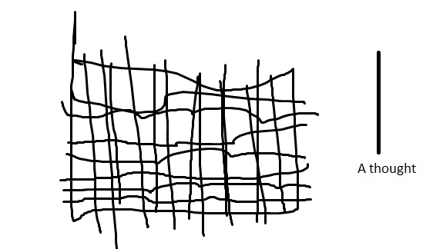

This is a spider web, as you see, or maybe not. Every line (view “A thought”) is connected to each other. Every line (“Thoughts”) is making your reality as you see it. Every line forms you as you, and nobody else. Every line connected to each other, makes your identity.
So let’s take an example to make it easier to understand how powerful the human brain is. I say you are ugly and stupid, your response will mostly be “Not I’m not”. What happens inside your brain is that you’re finding evidence and linking thoughts of why you are not stupid or ugly. “I have won swimming contest, I’m not ugly”, “I have A and B on school, I’m not stupid”.. And it goes on like that..

