FOCUSMAGAZINEMay 2010
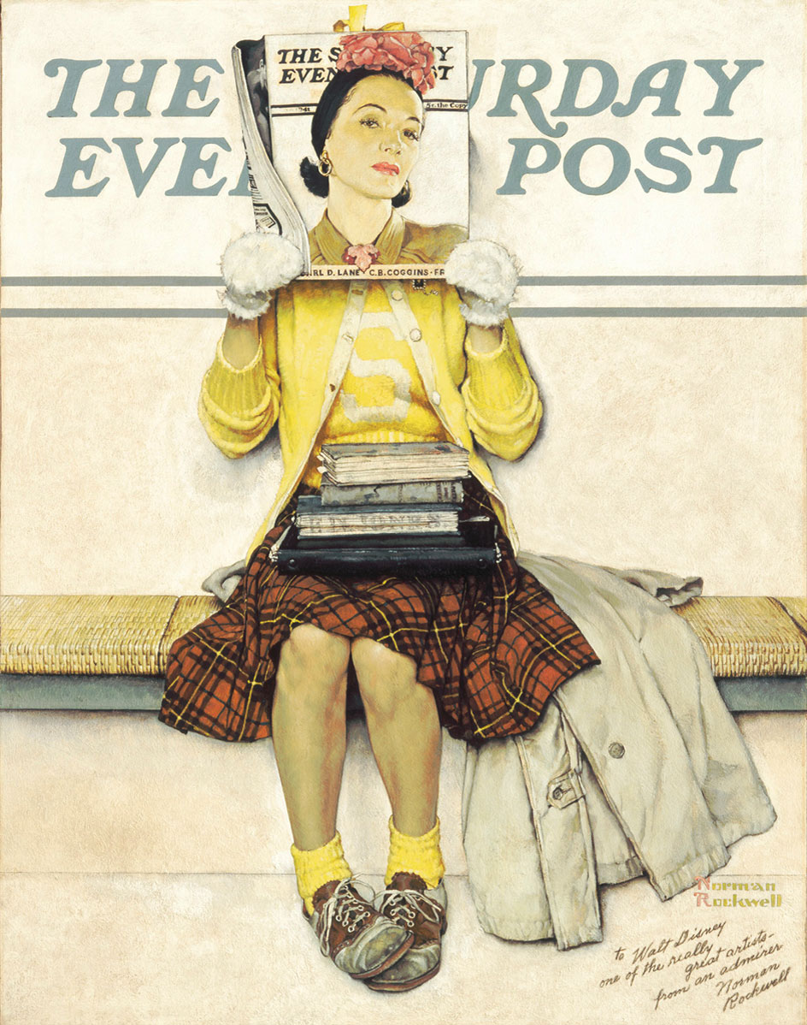
Source: images.google.no/imgres?imgurl=http://lh3.ggpht.com

Part BFocus on fiction
Norman Rockwell was an American illustrator and painter. He made the cover illustrations for The Saturday Evening Post for many years.

Part B: Focus on fiction

Bud, not Buddy
By Christopher Paul Curtis
It’s 1936, in Flint, Michigan. Bud Caldwell has been living in an orphanage since his mother died when he was six. He is sent to live with a foster family, but things don’t work out, so Bud is on the run. He needs to find his father, although he is not sure who his father is. The book is the story of Bud’s journey. Most of the people he meets on his journey are kind to him.
At this stage in the story he has met up with another boy from the orphanage called Bugs. They plan to jump a train to get out west where they can pick fruit and earn some money. First they have to find somewhere called Hooperville. Everyone waits there to jump the trains early in the morning. They find ‘another cardboard jungle’. Is this the place they want to be?
Extract from the book
I moved out from behind our tree and walked over to the biggest fire, I waited until some folks noticed me, then said, “Excuse me, is this here Hooperville?”
The man playing the mouth organ stopped and everyone else around the fire looked up at me.
One of the white men said, “What is it you’re looking for?”
I said, “A city called Hooperville, sir.”
They all laughed.
The mouth organ man said, “Naw, son, what you’re looking for is Hooverville, with a v, like in President Herbert Hoover.”
I said, “Oh, is this it, sir?”
The man said, “This is one of them. They’re all over the country, this here is the Flint version.”
“And all of them are called Hooverville?”
“That’s right, Mr. Hoover worked so hard at making sure every city has got one that it seems like it would be criminal to call them anything else.”
I said, “Well, how’re we going to know if we’re in the right one?”
The mouth organ man said, “Are you hungry?”
“Yes, sir.”
“Are you tired?”
“Yes, sir.”
“Are you scared about what’s going to happen tomorrow?”
I didn’t want anyone to think I was a baby so I said, “Not exactly scared, sir, maybe I am a little bit nervous.”
The man smiled and said, “Well, son, anyplace where there’re other folks in need of the same things that you are is the right place to be. This is exactly the Hooverville you’re looking for.”
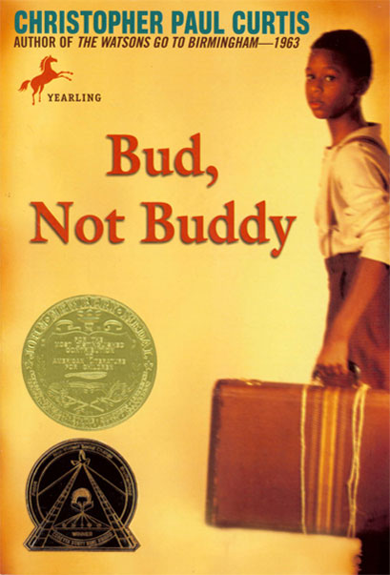
Source: josh3736.net/mcl/blog/?view=plink&id=115

Part B: Focus on fiction
Hoovervilles are camps that were set up on the outskirts of American cities and towns during the 1930’s depression. Angry, hungry and cold Americans blamed President Hoover for the downfall of the economy and felt he failed to help those who needed it the most, and therefore they named the camps after him.
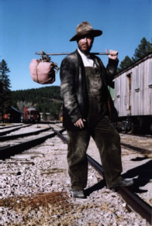
Getting on the trainwww.untoldentertainment.com/ blog/img/2009_08_17/hobo.jpg
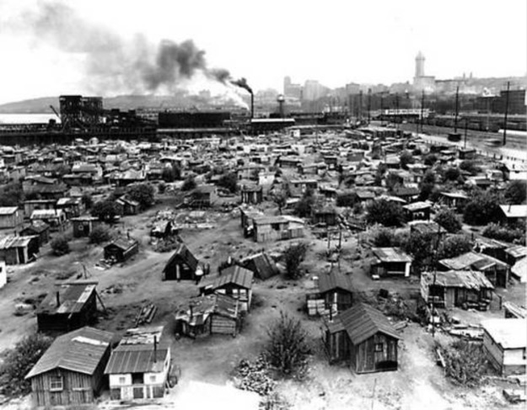
Source: Hooverville kaos radioaustin.org
Hooverville is the popular name for towns built by homeless people during the Great Depression.
There were more people sitting around than I first thought, mostly it was men and big boys, but there were a couple of women every now and then and a kid or two. They were all the colors you could think of, black, white and brown, but the fire made everyone look like they were different shades of orange. There were dark orange folks sitting next to medium orange folks sitting next to light orange folks.
“All these people,” the mouth organ man said, “are just like you, they’re tired, hungry and a little bit nervous about tomorrow. This is the right place for y’all to be ‘cause we’re all in the same boat. And you boys are nearer to home than you’ll ever get.”
As it turns out, Bugs jumps the train, but Bud decides at the last minute not to risk it. Instead he sets off to walk – west!
I walked and walked and walked. Some of the time a car would come by and I’d have to duck into the bushes and wait till it had passed, so I don’t think I was doing any five miles an hour.
Another car bounced over the top of the hill. I ducked into the bushes again.
The guy in the car stepped on the brakes to slow down and I could see him twist his neck around.
He stuck the car in reverse and pulled to a stop about thirty giant steps away from where I was hiding, His door opened and he stepped out and started walking slow toward my bushes. He brushed his hand over his head and put on a black hat like the kind the police and some army men wear. But all the cops I’d ever seen were white so I knew this guy must be a soldier.
He stopped and put his fingers to his lips and whistled. The whistle was so loud that it made me duck down and put my hands over my ears, it felt like he’d blown it right inside my head. All the bugs and toady-frogs shut right up, they quit chasing and biting each other ‘cause this had to be the loudest whistle they’d ever heard too.
He waited, then yelled, “Say hey! I know my eyes aren’t what they used to be, but I know they aren’t so bad that they’d lie to me about a young brown-skinned boy walking along the road just outside Owosso, Michigan, at two-thirty in the morning.”
I couldn’t tell if he was talking to me or to himself.
“Son,” he said, “this is no time to play. I don’t know and I don’t care why you’re out here, but let me tell you I know you’re a long way from home. Are you from Flint?”
Something was telling me to answer him but I still wanted to get a better look.
“From the quick look I got at you, you seemed a little on the puny side. I’ll bet you’re hungry. Just so happens that I’ve got a spare baloney and mustard sandwich and an apple in the car. You interested?”
Shucks. How did he know I was so hungry?
Then he said, “Might even have some extra red pop.”
Before my brain could stop it my stomach made my mouth yell out, “But I don’t like mustard, sir.”
Bud and the man enter into some long negotiations before Bud finally comes out of hiding in the bushes. He really wants that bottle of pop.
... I walked right up to the man like I was hypnotized. I forgot all my manners and reached right out (for the bottle of red pop).
He raised the bottle over his head. “Hold on now.”
“Could I have some of the pop, sir?”
He said, “I’ve got a problem and I need you to help me figure it out.”
Uh-oh. What he’d just said is another one of Bud Caldwell’s Rules and Things for Having a Funner Life and Making a Better Liar Out of Yourself. This was Number 87.

Rules and things number 87
When an Adult Tells You They Need Your Help with a Problem Get Ready to Be Tricked – Most Times This Means They Just Want You to Go Fetch Something for Them.
The man said, “My problem is that I’m not quite as brave as you are. I’m feeling very, very uncomfortable standing on the side of the road just outside of Owosso, Michigan, at two-thirty in the morning, and the sooner you can put my mind at ease about what you’re doing here the sooner we can both go about our business, OK?
I nodded. I was too doggone tired and hungry to think up a good lie. “Nothing, sir.”
He looked disappointed. “What’s your name, son?”
“Bud, not Buddy, sir.”
“Now there’s an unusual name. Did you run away from home, Bud-not-Buddy?”
I could tell this guy was poking fun at me but I answered anyway. “Yes, sir.”
“OK, that’s a start.”
He handed me the bottle of red pop.
And that is just the beginning of Bud’s meeting with Lefty Lewis, who is definitely one of the good guys.
Extract from Bud not Buddy by Paul Curtis, pages 66, 98 and 102.
http://eduscapes.com/reading/bud/activity3.htm

Part B: Focus on fiction
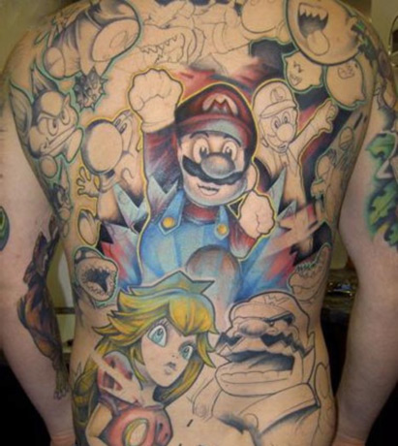
Source: www.thebbps.com

Skin
By Roald Dahl
It was in the winter of 1946, in Paris. The old man was shuffling along the street without paying any interest to the things in the shop windows - expensive shirts and ties, fine books. Then he saw a picture gallery. This Gallery had just one single painting in the window. He stopped to look at it. He looked again. Below the picture, there was a little plaque which read: Chaïm Soutine (1894-1943).
Drioli stared at the picture. Chaïm Soutine…Soutine…”By God!” he cried suddenly, “My little Kalmuck that’s who it is!”
How he could paint! It was all coming back more clearly now. Where was it the boy had lived? The Cité Falguière, that was it! Where he had his tattoo shop. How easily it all came back to him now:
The little Kalmuck (Soutine) had often come to his tattoo shop. And there was that business about the tattoo! Yes, now he remembered! He, his wife Josie, and the little Kalmuck, who was indeed this Chaim Soutine, had spent a night together. They decided that the little Kalmuck should make a picture of his wife by tattooing a large tattoo of her on Drioli’s back.

< førre
neste >

Part B: Focus on fiction
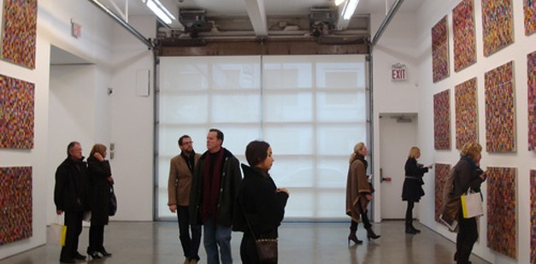
Source: www.mediabistro.com/fishbowlny/original/crowd2.JPG
It had been so long ago, all that - almost as though it had happened in another life.
Up to a few moments ago he had forgotten that he had a tattoo on his back. It had been ages since he had thought about it. He put his face closer to the window and looked into the gallery.
Suddenly Drioli pushed open the door of the gallery, and went in.
He wondered whether he should go forward. But before he had time to make up his mind, a voice beside him said, “What is it you want?”
“If you please,” the man was saying, ”leave my gallery.”
“Am I not permitted to look at the pictures?”
“I have asked you to leave.”
“Let us not have trouble,” the man was saying. ”Come on now, this way.”
“I, too!” Drioli was shouting “I, too, have a picture by this painter!”
“He’s mad.”
“I’ll show you! I’ll show you!” He threw off his coat, then his jacket and shirt, and he turned so that his naked back was towards the people.
“There!” he cried “You see? There it is!”
Everybody stood still. They were staring at the tattooed picture. It was still there, the colours as bright as ever. But the man’s back was thinner now, and that gave the picture a strangely wrinkled appearance.
The people crowded round the old man.
“It’s fantastic, fantastic!”
“And look, it is signed!”
“Old man, when was this done?”
“In 1913, ”Drioli said, without turning round.
“Who taught Soutine to tattoo?”
“I taught him.”
“And that woman?”
“She was my wife.”
The gallery owner was quiet now, very serious, making a smile with his mouth.
“Monsieur,” he said, “I will buy it.”
“How can you buy it?” Drioli asked softly.
“I will give you two hundred thousand francs for it.”
“Don’t do it!” a voice said in the crowd. ”It’s worth twenty times as much.”
“Monsieur, how can I possibly sell it?” he said in a very sad voice.
“Yes!” they were saying in the crowd. “How can he sell it? It is a part of himself!”
“Listen,” the dealer said, ”I will help you. I will make you rich.”
”But how can you buy it, Monsieur? What will you do with it when you have bought it? Where will you keep it? Where will you keep it tonight? And where tomorrow?”
“The picture itself is of no value until you are dead. How old are you, my friend?”
“Sixty-one.”
“I do not like this,” Drioli said, trying to get away.” I really don’t like this, Monsieur.” He went straight into the arms of a tall man. Drioli looked around. The man smiled down at him.
“Listen my friend,” the man said, still smiling, ”do you like to swim and lie in the sun? Do you like fine food and good wine? Do you like such things?”
“Well…yes,” Drioli answered, still not understanding what he meant. ”Of course.”
“And the company of beautiful women?”
“Why not?”
“And lots of suits and shirts made for you? It would seem that you are in need of clothes. Have you ever had shoes made for your own feet? Would you like that?”
“Well…”
“And a bell beside your bed to call the maid to bring your breakfast in the morning? Would you like these things, my friend? You see, I am the owner of the Hotel Bristol in Cannes. I now invite you to come down there and live as my guest for the rest of your life. You would like that?”
There was no answer.
“Don’t you see, all the guests will be able to look at this marvellous picture by Soutine. You will become famous, and men will say,” Look there is the fellow with ten million francs upon his back. ”Do you like this idea, Monsieur? Does it please you?”
“But do you really mean it?”
“Of course I mean it.”
“Wait,” the dealer said.” See here, old man. Here is the answer to our problem. I will buy the picture, and I will arrange with a surgeon to remove the skin from your back. Then you will be able to go off on your own and enjoy the great sum of money I shall give you for it.”
“With no skin on my back?”
“No, no, please! You don’t understand. This surgeon will put a new piece of skin in the place of the old one. It is simple.”
“Could he do that?”
“There is nothing to it.”
“Impossible!” said the tall man.” He is too old for such an operation. It would kill him. It would kill you, my friend.”
“It would kill me?”
“Of course. Only the picture would come through.”
Then the tall man put his hand on Drioli’s shoulder again. ”Come on,” the man was saying, smiling his broad white smile. ”You and I will go and have a good dinner and we can talk about it some more while we eat. How’s that? Are you hungry?”
Drioli watched him. He didn’t like the man’s soft voice, nor the way he put his hand on his shoulder.
“Roast duck and Chambertin,” the man was saying.
Drioli’s lips became loose and wet.
“I’m coming,” Drioli said quickly. “Wait for me. Monsieur. I am coming.”
It wasn’t more than a few weeks later that a picture by Soutine, of a woman’s head, painted in an unusual manner, turned up for sale in Buenos Aires. That - and the fact that there is no hotel in Cannes called the Bristol - causes one to wonder a little, and to pray for the old man’s health, and to hope that wherever he may be at this moment, there is a beautiful maid that brings him his breakfast in bed in the mornings.
Shortened

