FOCUSMAGAZINEMay 2010
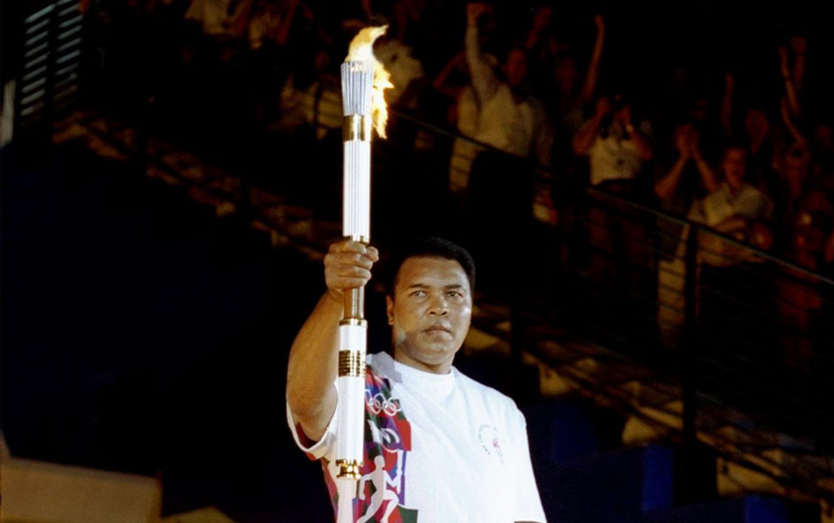
Source: gonyc.about.com/od/chrisstmassights/ss/2005_bloomies_9.htm

Alternative A3Focus on boxing
Muhammad Ali, once a World Heavyweight Champion, now suffering from Parkinson’s Disease, struggled to climb the steep stairs of the stadium before his shaking hand held high the Olympic Torch in 1996.

Alternative A3: Focus on boxing

Warhol classics stolen from private collector
Los Angeles police are hunting for a multi-million dollar collection of ANDY WARHOL artwork stolen from a private collector earlier this month. Authorities were called out to the home of businessman Richard Weisman after he found 10 pieces of his Warhol collection had been taken.
The paintings, hailing from the 1970s and depicting images of Muhammad Ali, O.J. Simpson, and other athletes, were noticed missing by a staff member. L.A. Detective Mark Sommer says, "This was a very clean crime. (The home) wasn't ransacked."
Weisman is offering a $1 million (£666,000) reward for the safe return of the artworks.
Source: www.contactmusic.com/news.nsf/story/warhol-classics-stolen-from-private-collector_1115824
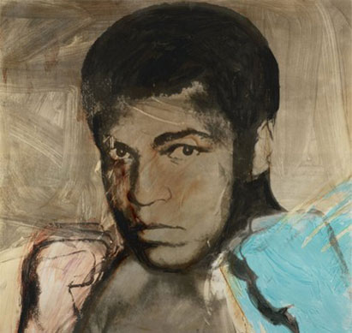
Made by Andy Warhol
Source: www.coskunfineart.com/works.asp?artistID=9
Great Sporting Moments: Muhammad Ali v George Foreman, World Heavyweight title fight, Kinshasa, Zaire, 30 October, 1974.
One was a huge and apparently invincible ogre. The other was past his best, with question-marks over his stamina – and, some said, over his ability to survive the beating that awaited him. No one could have imagined what really lay in store, when Foreman faced Ali in Zaire in 1974.
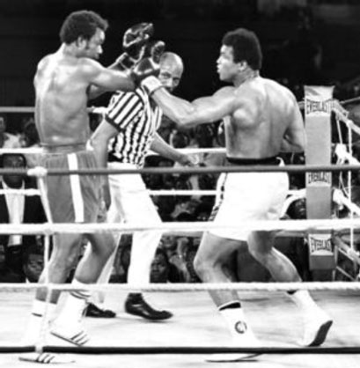
Source: www.gettyimages.com/detail/80109589/AFP
Ali’s comments on the fight:
"Muhammad Ali stops George Foreman. I kicked a lot of asses – not only George's. All those writers who said I was washed up, all those people who thought I had nothin' left to offer but my mouth, all them that been against me from the start and waitin' for me to get the biggest beatin' of all times. They thought big bad George Foreman, the baddest man alive, could do it for them, but they know better now."
"I fooled everybody. They thought I'd have to try and dance against George, that my legs would go and I'd get tagged. George thought so, too. But that was my main thing, not dancin'. The trick was to make him think he was the baddest man in the world and everybody had to run from him."
"Truth is, I could have killed myself dancin' against him. He's too big for me to keep moving around him. I was a bit winded after doing that in the first round, so I said to myself: 'Let me go to the ropes while I'm fresh, while I can handle him there without getting hurt. Let him burn himself out. Let him blast his ass off and pray he keeps throwin'. Let it be a matter of who hits who first, and that's me.' This was a real scientific fight, a real thinkin' fight. For me, it was. Everythin' I did had a purpose."
Source: www.independent.co.uk/sport
I am the astronaut of boxing. Joe Louis and Dempsey were just jet pilots. I'm in a world of my own.
Muhammad Ali
In those days, boxing was very glamorous and romantic. You listened to fights on the radio, and a good announcer made it seem like a contest between gladiators.
Joseph Barbera
1867 is an important date in boxing history as that is when the Marquess of Queensberry rules were drafted in London by John Chambers. These 12 rules, published under the patronage of the Marquess of Queensberry, ushered in the modern era of boxing.
The rules specified such now-accepted practices as a standard square ring, three minute rounds with one minute rest between rounds, and a ten second count for a knocked down fighter to rise to his feet. Equally important was the introduction of gloves which resulted in longer, more strategic bouts and, overall, a less brutal sport.
Source: www.britannica.com/EBchecked/topic/366079/Marquess-of-Queensberry-rules

Alternative A3: Focus on boxing

Women in boxing
Although women’s boxing will see its debut during the 2012 Olympic Games in London, women have had their place in the boxing ring for many years.

Source: www.boxnews.com.ua/photos/1392/Cecilia-Braekhus2.jpg
Cecilia Braekhus started her fighting career as a successful kick-boxer before she turned to boxing at the age of 22. After 80 fights, the 28 year-old Colombian-born boxer is believed to be a future World Champion many times over. Braekhus turned pro in January 2007, becoming the First Lady of women’s boxing, and promptly signed a contract with the German-based Team Sauerland as the first woman ever.
After landing her contract with Sauerland Braekhus said: “For me it is an honour to be the first woman working with such a renowned boxing promoter. And now I would like to become the first female World Champion in our team.” Revered by fans in countries such as Germany, the USA and Norway, Braekhus will be an important and popular addition to the women’s debut in the Olympic boxing ring.
Source: www.first-lady-cecilia.com
"I did not enjoy the violence of boxing so much as the science of it."
Nelson Mandela
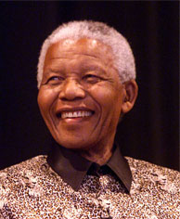
Source: www.africamasterweb.com
/AfricaMbebe/
MandelaPassport.jpg
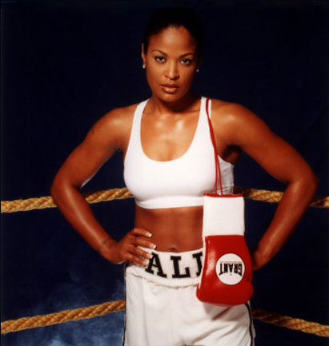
Source: tcarther.files.wordpress.com/2008/05/263177laila-ali-posters.jpg
As the daughter of boxing legend Muhammad Ali and the World Heavyweight Champion, Laila Ali entered the world of professional women's boxing in 1999 at the age of 21. At that point Laila Ali had a degree in business management from Santa Monica College and was the owner of an upscale nail salon in Southern California. She had not considered following in her father’s footsteps until she saw a boxing match on TV and instantly felt drawn to the sport. She made the decision then to sell her business and begin training for a career in women’s boxing.
Before a fight in Johannesburg in 2007, Laila Ali met former South African president Nelson Mandela. In South Africa Nelson Mandela's love of boxing is well-known, and Laila told reporters gathered in Johannesburg that "Mandela is a very humble man and there is a lot of energy in the room and I could feel his spirit. I am very honoured to be here today." She won her fight.
Source: www.lailaali.com
www.fscclub.com/history/box-hist-e.shtml
These young female boxing champions will bring determination and integrity to the ring, giving the old and traditional sport a softer edge to it for the world to see in 2012.
Remember, beauty is only skin deep and boxing is for many so much more than bloodied men and crooked noses.

Alternative A3: Focus on boxing
Muhammad Ali decided that he would not use his dancing techniques in the fight against George Foreman. But Billy Elliot actually ended up in the dancing class when he should have been learning to box.

Billy Elliot
Screenplay by Lee Hall
Easy reader based on the screenplay by Melvin Burgess
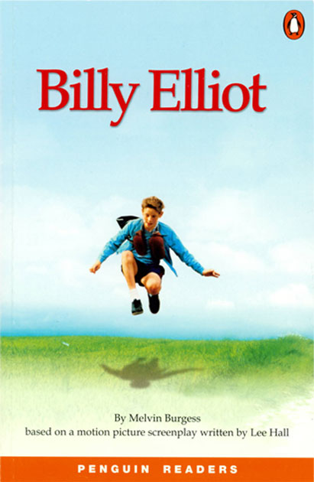
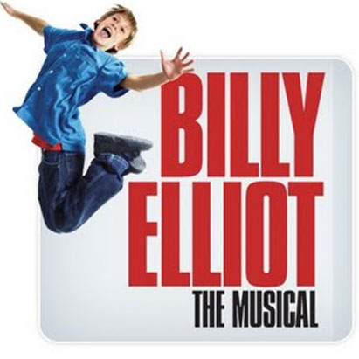
Source: steveonbroadway.blogspot.com/2007/08/
billy-elliot-set-to-make-imperial-leap.html
Billy Elliot was written first as a screenplay in 2000 and then as a book by Melvin Burgess in 2001. The film and the musical have won endless awards on both sides of the Atlantic.
Billy Elliot is the story of an ordinary 11-year-old living in a mining community in the northeast of England. His brother and his dad are miners. The story takes place in 1984-85. This is the time of the miners' strike, so tough times for miners. Like most of the other boys, Billy goes to boxing lessons.
Extract from the screenplay
On this particular evening there is a ballet class going on in the same hall as the boxing class. Billy’s Dad comes to watch him. George is the boxing teacher. Billy is fighting Greaves, a fat lad a good five inches taller than Billy.
George : Right then, lads. Now give it all you’ve got. Round one.
Billy comes tentatively out of his corner. There is a determination in his feet but his punches just don’t seem to land. He gets whacked.
George: Well don’t just stand there, Elliot.
George lets them spar again. Billy dances round. He appears to be enjoying the dancing around more than the boxing as he bounces around indiscriminately.
George: Oh no, not again. This is man-to-man combat, not a bloody tea dance.
George looks over to Dad who shakes his head.
George: What are you doing man? Hit him!
Billy sees one of the ballet girls and smiles.
George: He’s just pissin’ about. Now get stuck in and give him a belt.
Dad (off screen): Billy, hit him!
We see a huge glove coming straight towards Billy’s face. Bang. Billy is flat out on the ground.
George: Jesus Christ, Billy Elliot, you’re a disgrace to them gloves, your father and the traditions of this boxing hall. ... You’re not going ‘til you do it properly.
Billy starts swinging wildly at the bag in his anger. Music is playing from the dance class which is in full swing at the end of the music hall, obscured by the boxing ring. He calms down and tries to hit the bag properly. George throws Billy the keys, amazingly Billy catches them in his gloves.
Extract from the screenplay by Lee Hall, pages 6-8.
Extract from the easy reader
‘Give those to Mrs Wilkinson when you finish. I’ll see you next week.’
He went out of the hall. Good. This bag is George’s head, I thought. I hit it harder.
I don’t like boxing. My friend Michael is right – it’s stupid.
I took off the gloves and walked across the hall. The girls were pretty in their pink dresses, but I felt a bit uncomfortable.
‘Miss, the keys ... the keys, Miss!’ I said.
The music started again and the girls danced. They were clever. They all lifted their arms at the same time and they turned round. It was interesting – but it was easy. I can do that, I thought. I lifted my foot. See? Easy!
I moved with the girls, but it was very difficult. Up and down and one and two and three and four ...
‘Take your boots off!’
‘Ow!’
Miss was standing on my foot.
Take off my boots? Why? I didn’t know, but I took them off. Then she dropped a big pair of ballet shoes in front of me.
‘Put them on,’ she said. ‘You can’t dance in those boots.’
So I put on the shoes. Nobody saw me except the girls. And do you know something? I think they liked me in their ballet class.
Extract from Billy Elliot by Melvin Burgess, slightly shortened pages 6-7.

Alternative A3: Focus on boxing
I was drawn to boxing because I got beat up as a kid. I was the kid with the piano books in a New York neighbourhood.
Billy Joel

So should young people learn to box?

Yes
- Boxing teaches young people the important fact that actions have consequences – as in the real world.
- Boxing keeps young people fit – a good way to reduce the growing problem of obesity.
- Boxing provides troubled young people, especially teenage boys, with the opportunity to explore, make mistakes, compete and let off steam. This is not encouraged at school.
- Boxing communicates with young people on their own terms – it recognises the aggression and frustration common in teenagers.
- Boxing gives young people who may never have been good at anything else a sense of worth and self-esteem. Boxing gives them confidence.
Source: http://www.telegraph.co.uk/comment/3554643/End-the-woes-of-Britains-children-with-boxing.html

No
- There is real danger that young people will be hurt – even sustain brain damage during fights.
- Boxing encourages aggression.
- Young people are unable to assess the serious risks of boxing.
- Being able to box means that young people, especially boys, know how to hurt others and so feel confident to do so.
Source: http://news.bbc.co.uk/1/hi/health/265121.stm

