FOCUSMAGAZINEMay 2010
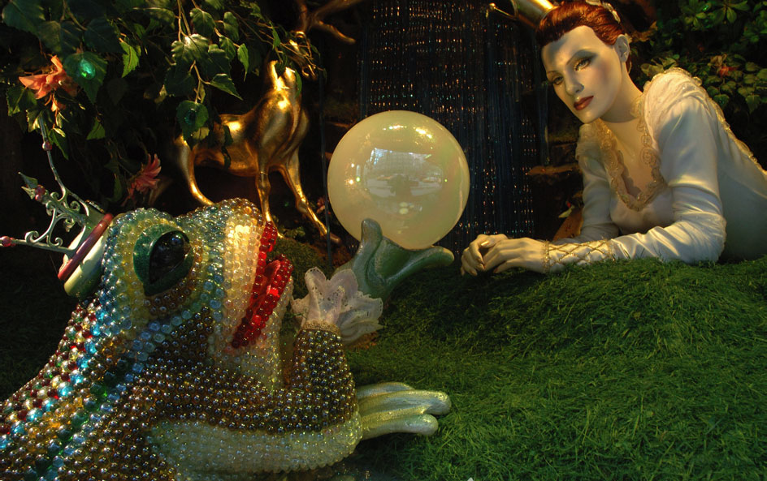
Source: gonyc.about.com/od/chrisstmassights/ss/2005_bloomies_9.htm

Alternative A2Focus on changing me

Alternative A2: Focus on changing me

Queenbees and Wannabees
By Rosalind Wiseman
Extract from the book


It wasn’t so easy
One of the things I always felt growing up as someone of mixed racial heritage was that I didn’t fit anywhere. On the one hand, I was presented with the white image of beauty as the blue-eyed, blond haired, tall, skinny, big-breasted All-American girl. On the other hand was the Asian image of beauty as petite, slender, long dark hair, exotic features, and pale skin, actresses like Lucy Liu, Ming Na Wen, and the women in Crouching Tiger, Hidden Dragon.
The only thing I had in common with any of those images was that I was fair-skinned, otherwise I never felt like I measured up.
For people of mixed backgrounds, you kind of fall through the cracks when you look at fashion magazines. It’s also true that Asian women try to look more white. My mother, for instance, puts tape on her eyelids to make them look rounder. One of my Korean friends once told me I was lucky that I had pale skin because when she went to Korea, people told her she looked like "a country girl" because she’s naturally tan. There are also operations that some girls get to make their eyes look more "white," and some girls get nose jobs to make their noses look more "white."
This doesn’t occur only in the States either; in Korea, plastic surgery is a huge industry. It’s because they also get Western fashion magazines there and are presented with the Caucasian standard of beauty and will get nose jobs, fix their eyes, and get operations on their jaws to make their faces look less round, less Asian and more white. When you look at women like Jennifer Lopez and Beyonce Knowles, who both have blond highlights and look like white women with tans, you realize that racism still plays itself out in what we are presented with as "beautiful."
Growing up and going to school in a town with a large minority population, I thought I was ugly because I didn’t look like any of my friends. It didn’t help that I was a late bloomer and was an extremely awkward adolescent. I had a sudden growth spurt and it took me a while to figure out what to do with arms and legs (clumsy is an understatement). I had straight hair where most of my friends had dark curly hair, I was tall, pale, skinny, and flat-chested, where most of my friends were shorter than I was, had curvy figures, and brown or black skin. Even if girls were my height or taller, they still had curves where I didn’t.
The prettiest and most popular girls in my school looked nothing like me and this made me feel ugly in comparison. It was a reversal of wanting to fit the blond, blue-eyed ideal, I wanted to look less white and like more of a minority. It was actually a double-bind because by white standards I wasn’t beautiful either, because I wasn’t blond, blue-eyed, with a big chest. Even so, I rejected the blond image of beauty in favour of wanting to make more of being a minority because I wanted to be accepted in school and be pretty by those standards.
Ellie, 21
Extract from Queen bees and Wannabees by Rosalind Wiseman, pages 87-88
http://kidshealth.org/teen/your_mind/body_image/body_image.html

The secret diary of Adrian Mole Aged 13 ¾

Friday March 13th
The emergency doctor came to my grandma’s last night at 11.30 p.m. He diagnosed that I am suffering from acne vulgaris. He said it was so common that it is regarded as a normal state of adolescence.

Wednesday March 24th
The only thing that really worries me about my appearance now is my ears. They stick out at an angle of ninety degrees. I have checked them with my geometry set so I know it is a scientific fact.
Extracts from The secret diary of Adrian Mole aged 13 ¾ by Sue Townsend, pages 45,46 and 84.
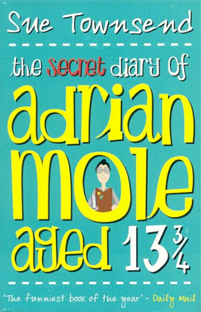

Alternative A2: Focus on changing me

My life as a giraffe
By Arianne Cohen, The Observer,
Sunday 31 May 2009
Most men dream of being 6ft 3in tall, but for women the climb is not nearly as smooth. Pressured to take growth inhibitors at 11, on the therapist's couch at 17, Arianne Cohen only grew to love her stature when she dated a 7ft 2in man. Here, she shares the dizzying highs and lows of life.
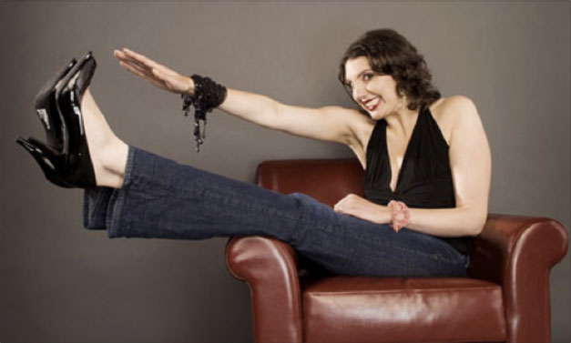
Photograph Barry J.Holmes
The true challenge of tall life is not that you’re tall. Who cares about that - legs are legs.
The challenge is everyone can see you, all the time. You’re on display.
At least my mother was on my side. She had smartly overloaded my schedule with activities where height was an asset - tennis, dance, swimming.
One day in Dr Kauger's waiting room, I watched adorable chemo-stunted boys and girls play below walls muralled with giraffes. Children's illustrators often use giraffes as a neutral mascot of difference. Lynn Sherr, the tall American news anchor wrote: "Because of its height, the giraffe has long been a symbol of people who just don't fit in. They may be too tall or too eccentric, or simply too different from everyone else, like exclamation points on the landscape."
An exclamation point. That is exactly what I felt like!
I was the sort of child who read. That afternoon I went to the library. The card catalogue said, "Tall: see Giraffe". No mention of "oestrogen" or "height-reduction treatment". I found a book about Memily, by children's writer Stephen Cosgrove: "Week after week, Memily grew and she became sadder and sadder. She was shy and embarrassed by her height, and whenever any of the other creatures walked by she would turn her head, knowing that they had to look up just to look her in the eye." Memily develops a severe slouching problem. So did I.
But Memily, apparently, was never offered oestrogen therapy. So I had to make the decision alone. My thinking had little to do with height and more to do with a general aversion to medication: when in doubt, don't take chemicals. At the time, it was simply a decision of passivity. I was frozen. Though I wasn't happy with my body, I didn't want to change it. I told myself that the fastest swimmers in the world were six-footers. Long limbs were important. So I decided to not do anything. I figured I'd just wait and see what happened.

There are ways to change your appearance. Sometimes it works, sometimes it doesn’t work and sometimes it is drastic.

Tattoo clue led police to thief
A car thief who had his name and date of birth tattooed on his neck was caught after CCTV images of him were used to track him down.
Aarron Evans, 21, pleaded guilty at Bristol Magistrates' Court to breaking into a covert capture car in the city. The car had been left by Avon and Somerset Police officers with a covert camera concealed inside, which took pictures of Evans. Evans, an illiterate man of no fixed address, was sentenced to seven months. Superintendent Ian Wylie said: "Criminals won't be tolerated in Bristol and we will keep catching them and bringing them before the courts.”
Source: www.poe-news.com/stories.php
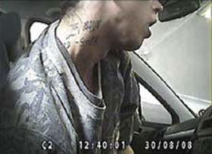
CCTV shows Evans breaking into the car.
It can happen to you and your tattoo.

Alternative A2: Focus on changing me
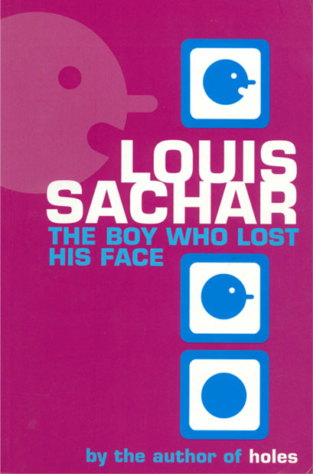

The boy who lost his face
By Louis Sachar
Extract from the book
AT RECESS he saw Scott and Roger and everyone hanging out on the steps. Roger was waving his arms, talking about something, and everyone else was laughing.
David sighed. He didn’t know what Roger was saying, but he doubted it was very funny. Still, he knew if he was there, he would have laughed too.
Leslie Gilroy was wearing Roger’s black vinyl jacket. That was one of the games they played. Whenever a girl wore a boy’s jacket it meant she wasn’t allowed to talk to another boy. Leslie wasn’t even allowed to talk to Randy or Scott without first taking off the jacket.
Leslie had long, silky, beautiful blond hair that she was always complaining about. It seemed whenever she wasn’t the center of attention, like when the guys were talking about sports, she’d suddenly say, “I hate my hair. It’s too straight. I wish it was like yours, Ginger.” Ginger had dark frizzy hair.
They stopped right in front of him. Leslie took off Roger’s black jacket and handed it to Ginger. Now she was allowed to talk. She turned to David and said, “No girl will ever want to wear your jacket. You’re the ugliest boy in the whole school.”
She took the jacket from Ginger and put it back on. Then the two girls turned and walked quickly back to their friends.
“I said it!” David heard Leslie exclaim. “I said it right to his face!”
“He didn’t do a thing,” said Ginger.” He just sat there.”
Extract from The Boy who lost his face by Louis Sachar, pages 43-44
Michael Jackson’s sudden and tragic death has revealed the truly iconic status he had achieved in the world. While some of the news media have chosen to continually harp on what they have labeled as Michael’s eccentricities, especially what they have called his bizarre appearance and behavior over the last few years, his 40 years of unbroken creativity and musical genius have secured his enduring iconic status in the minds of an adoring global public.
But he was also still himself – Michael Jackson struggled to live as normal a life as a genius child can live. Michael sensed that his public wanted more and the perfectionist in him demanded that he give more, become more, become larger than his human self, become larger than life. Along the way, he lost track of who he was.
Struggling to sustain the larger-than-life icon image, the public face and persona of superstar icon Michael, Michael Jackson became more and more confused and developed more and more distorted views of himself - of who and what Michael Jackson was. He needed to be fixed - to be transformed - to be perfected based on some external standards of beauty.
Numerous plastic surgeries and skin treatments killed the physical Michael Jackson and invented the new Superstar image – the icon. Ironically, in the final analysis, his iconic status had little or nothing to do with his physical appearance. The glove, the unique military-like dress, the penny loafers, the white or sequined socks, the moon walk and other dance moves were all props in the making of his iconic image.
Source: www.nypl.org/blogs/2009/07/07/Michael-jackson-icon
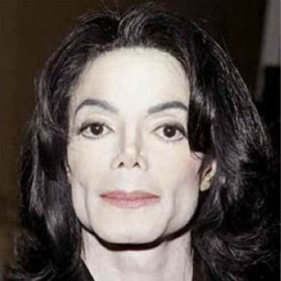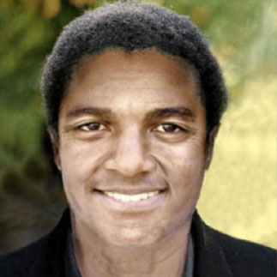
Source: struggleforfashion.blogg.no/images
An image of how Michael Jackson looked after many surgical operations and a computer manipulated image of him, showing how he probably would have looked without plastic surgery and possible skin whitening treatment.

Alternative A2: Focus on changing me

Sara's face
By Melvin Burgess
In this extract Bernadette, a former ward sister at Home Manor Farm, talks to the police, an Inspector Alderson. In this conversation Bernadette refers to the boy, who is Sara’s boyfriend.
“The boy says Sara thinks they want to steal her face.”
“Steal her face? How can they do that?”
“They can do that these days. It’s that Dr Kaye - he can do anything. Really anything.”
There was silence on the other end of the phone.
“I’m not saying it’s true,” begged Bernadette, trying very hard not to cry.” – I’m just saying that’s what she thinks. Now a girl that thinks that, she shouldn’t be going into surgery, should she? Don’t you think, Inspector? Don’t you?”
Bernadette ground to a halt, unable to speak.
“I’ll look into it. We’ll be in touch, Mrs McNalty.”
Bernadette put down the phone, put her head in her hands and cried. She had done what she could. Now it was in other hands than her own.
Inspector Alderson was at a bit of loss as to how to proceed. He put in a call to Home Manor Farm, where he got confirmation that yes, actually, an operation was taking place at that moment - very small, nothing much, a girl having some minor burn scars seen to and a few other bits and pieces. A little breast enhancement. The speaker wasn’t sure what, exactly.
At last, at long last, a network was rising up to help Sara. But so, so late! Even now, Dr Kaye was peeling away the flesh, while his assistant prepared Heat to receive her beauty. Despite her madness, it was exactly as Sara feared.
Before long the front gate was a blaze of TV lights. Images from Home Manor Farm, where a young fan was rumoured to be being subjected to facial surgery she had not consented to - surgery performed by Heat’s notorious surgeon, Dr Wayland Kaye - were being broadcast in every country in the world. There were even rumours that Heat was in the process of stealing her face.
Only half an hour before, Sara’s face had been plucked up from the front of her head and laid neatly on the bloodied front of Heat’s. There had as yet been no time to connect any nerves, but to move things further on, Kaye had stitched it on at the tip of his nose. Sara, meanwhile, lay unconscious, paralysed, faceless and expressionless under a sheet, a layer of sterilised tissue over her face to keep the wound fresh. The remains of Heat’s face had already been removed and incinerated.
The cameras snapped and rolled and revealed to the world the now famous image of Sara’s face, inert in a way no face ever should be. But it wasn’t Sara who was wearing it – it was Heat himself.
Extract from Sara’s Face by Melvin Burgess, pages 219,220,226,228 and 229.
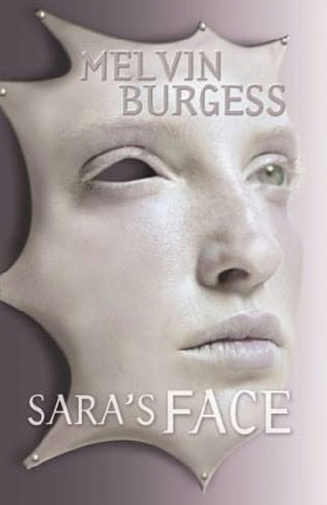
Times have changed. Young girls dream of operations like this. It’s like buying new clothes these days. Sara Carter wants to be famous. Fame is her obsession. So when legendary rock star Jonathon Heat offers her star training and the cosmetic surgery she thinks she wants, Sara can’t believe her dream will come true.

