FOCUSMAGAZINEMay 2010
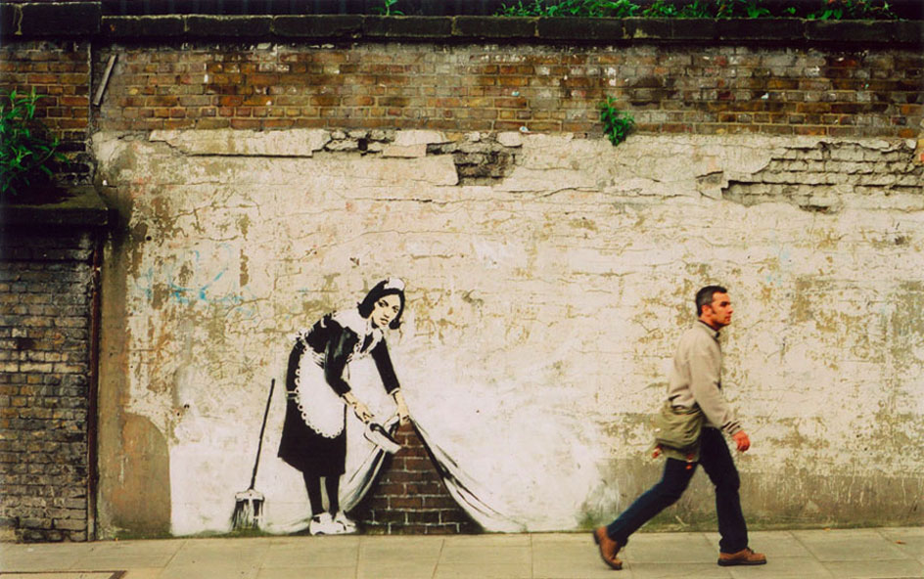
Source: pimpinandcrimpin.com

Alternative A1Focus on street life
The street artist known as Banksy is a mystery. Nobody knows who he is or where he lives but a lot of people know his street art. Banksy often combines graffiti with comments on politics, culture, or ethics. Where will his next piece of art appear?

Alternative A1: Focus on street life

Public to decide art or graffiti?
People living in Bristol may be asked to vote on whether graffiti should be left on buildings or removed, in an attempt to promote street artists.
Under the plan, the city council will ask the public to decide whether murals are art or graffiti tags. As part of a street art policy, council contractors will not take action if people vote to keep wall paintings.

Positive contribution
Although the council has pledged to remove offensive and unsightly graffiti, a street art policy will "seek to define and support the display of public art".
The plan states that "where people tell us that murals or artworks make a positive contribution to the local environment and where the property owner has raised no objection" the council will not remove the graffiti.
Councillor Gary Hopkins said: "We have said informally that if it is street art that people like we will keep it, but we want to formalise it now into a policy.”
"Tagging will still be removed, but if it is art that people say they want to see, they can take a photo and upload it on to our consultation website and we will ask people what they think."
Source: www.telegraph.co.uk

Source: "ferretfacejones"

Portrait of the street artist who gave America an icon
By Leonard Boyle
Saturday, 10 January 2009
Shepard Fairey’s images often landed him in jail - now he hangs at Washington’s National Gallery.
From skateboarder to famous street artist, Shepard Fairey has seen the inside of numerous police cells in his long career. The artist’s most recent arrest was last August when he was in Denver for Mr Obama’s nomination to stand as the Democratic presidential candidate. He was busy postering an alleyway with some friends while a film crew documented their work, when riot police showed up.
While Mr Obama was accepting the Democratic nomination, Fairey, out of jail with a slap on the wrist, was already filming a YouTube account of the 14th arrest in his meteoric career as America’s foremost street artist. Emerging from humble beginnings in the back alleys of Los Angeles, the portrait became an instant sensation, a pop culture “icon” that was willingly embraced by the Obama political Machine.
The portrait has become part of the Smithsonian’s permanent collection at the National Portrait Gallery, which is conveniently only a few blocks from the White House. The portrait gallery is better known for its stuffy collection of George Washington portraits than street art, but the museum’s curator, Carolyn Kinder Carr, said simply:” We all fell in love with it. We always like portraits that reflect a particular moment in history, and we like the fact that it is an image that resides in popular culture.”
Source: www.independent.co.uk
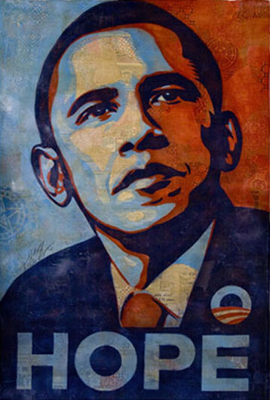
Source: National Portrait Gallery,
Shepard Fairey

Alternative A1: Focus on street life

Play me I'm yours
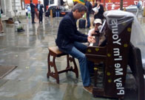
Source: www.streetpianos.com/ london2009/pianos/st-mary-le bow
Touring internationally since 2008, 'Play Me, I'm Yours' is an artwork by artist Luke Jerram. Street pianos are appearing in cities across the world. Located in parks, squares, bus shelters and train stations, outside galleries, markets and on bridges and ferries, the pianos are for any member of the public to enjoy and claim ownership of. 112 pianos have been installed so far.
Many pianos are personalised and decorated. Who plays them and how long they remain is up to each community. Each piano acts as a sculptural, musical, blank canvas that comes to reflect the community where it is placed.
Source: www.streetpianos.com
http://kids.tate.org.uk/games/street-art
Many young people are kept off the streets by playing a sport or becoming involved in music.
Many young people are kept off the streets by playing a sport or becoming involved in music. They focus on running or playing football or table tennis or singing in a choir or playing in a group. But Khadijah Williams focused on school - it was her ticket to not living on the street.

From homeless to Harvard

Khadijah at her graduation.
Source: seattletimes.nwsource.com
"She has attended 12 schools in 12 years; lived out of garbage bags among pimps, prostitutes and drug dealers."
By Esmeralda Bermudez
Los Angeles Times
Here is an extract from a newspaper article in The Seattle Times about Kahdijah.
As long as she can remember, Khadijah Williams has floated from shelters to motels and back to shelters along the West Coast with her mother. She has attended 12 schools in 12 years; lived out of garbage bags among pimps, prostitutes and drug dealers. Every morning, she made sure she didn't smell or look hopelessly untidy.
Williams was in third grade when her teachers marked the 9-year-old as gifted. In the years that followed, her mother pulled her out of school eight more times. When shelters closed, money ran out or her mother did not feel safe, they packed what little they carried and boarded buses to find housing in Los Angeles, San Francisco, Ventura, San Diego, San Bernardino and Orange County, staying for months, at most, in one place.
She finished only half of fourth grade, half of fifth and skipped sixth. Seventh grade was split between Los Angeles and San Diego. Eighth grade consisted of two weeks in San Bernardino.
In 10th grade, she realized that if she wanted to succeed, she couldn't do it alone. She began to reach out to organizations and mentors, teachers, counselors and college alumni networks. When she enrolled in the fall of her junior year at Jefferson High School, about five miles southeast of downtown Los Angeles, she was determined to stay put, regardless of where her mother moved.
This soon meant commuting by bus from an Orange County shelter. She awoke at 4 a.m. and returned at 11 p.m., and kept her grade-point average at just below 4.0 while participating in the Academic Decathlon, the debate team and leading the school's track and field team. "That's when I was really stressed," she said of that time.
Williams graduated with high honors, fourth in her class. She was accepted to more than 20 universities nationwide, including Brown, Columbia, Amherst and Williams. She chose a full scholarship to Harvard and hopes to become an education attorney.
Source: seattletimes.nwsource.com
www.khadijahwilliams.com

Alternative A1: Focus on street life
Khadijah Williams got off the street by studying hard. In Q & A, Ram gets off the street by being streetwise and VERY observant.

Q & A
By Vikas Swarup
Extract from the book
In this episode, Ram has had money to spend, but it has been stolen from him, so now he is back on the street. And his only thought is for...
Food. That is all I can see, hear, think and smell on the crowded and noisy railway station where I have been standing in my cotton shirt and Levi jeans for the past two hours. If you don’t eat for a while, the hunger just shrivels up and dies.
But if you don’t eat for a long time – and I have not had a meal since yesterday afternoon – your brain does funny things. All around me I can only see people eating and drinking. And my nose follows the trail of food like a dog sniffing out a bone. The aroma of freshly made jalebis, puasbasic as a boiled eggris and kachoris makes me dizzy.
But when I finger my pocket I discover only a one-rupee coin, and after last night’s loss of my fifty thousand rupees, it doesn’t seem lucky any longer. So I lick my parched lips and wonder how to kill my hunger.
My eyes fall on a hoarding next to the railway canteen. It says simply, ‘M - Just one kilometre away.’ I know instantly where I can get food. For free.
I leave Agra station and set about searching for the big M sign. I find it eventually in the heart of a posh market. The smartly attired waiters at McDonald’s look at me suspiciously but don’t shoo me away. They can’t turn back a customer in Levi jeans, however scruffy he might be. I position myself close to the wooden bin, the one with the swing flap. When no one is looking I quickly push my hand inside and take out as many of those nice brown paper bags as are within arm’s reach. I exit after using the clean toilet to wash off some of the dirt and grime from my face.
My first attempt at scavenging is quite successful. I sit on a green wooden bench outside and feed contentedly on a half-eaten vegetable burger, some chicken nuggets, two almost full packets of French fries and half a cup of 7Up. Scavenging is part of the survival gear of a street kid.
Extract from Q & A by Vikas Swarup, pages 273-274.

Slumdog Millionaire is the film version of Q & A.

Pictures from the film Slumdog Millionaire
Source: www.inewsindia.com/wp-content/uploads/2009/02/slumdog_millionaire.jpg
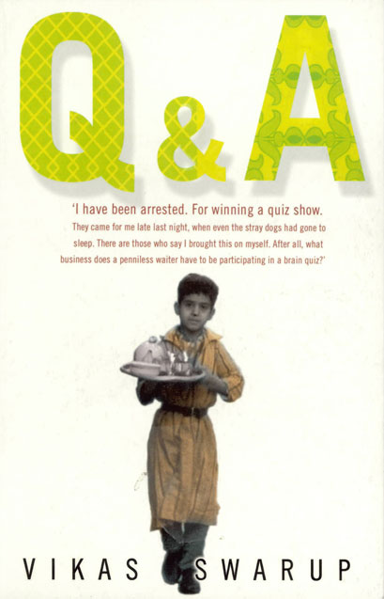

Alternative A1: Focus on street life
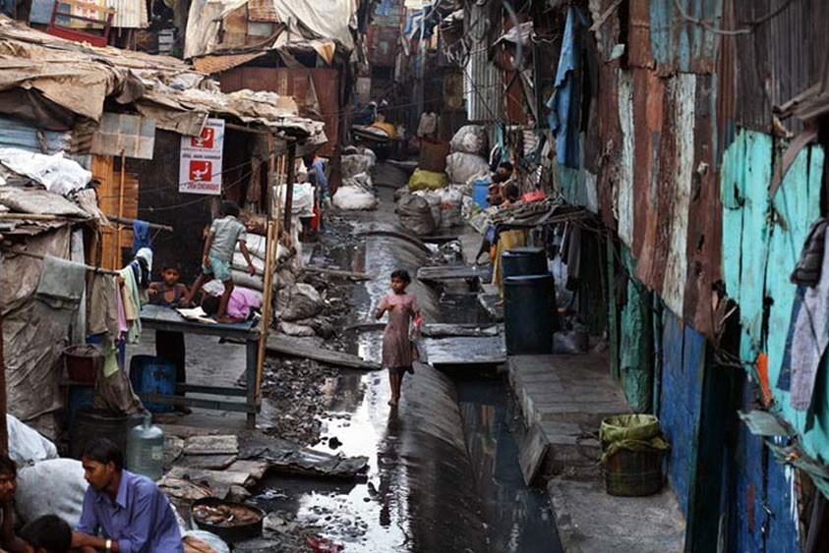
A neighborhood walk
Photograph Jonas Bendiksen
Two young children from the Mumbai slums were chosen to be the child stars of the film. When the film won eight Academy Awards in Hollywood in 2008, the young stars were there. So Sunday, Hollywood; Thursday, a Mumbai shanty town. Sunday night, Azharuddin Ismail and Rubina Ali slept in a luxury hotel. Thursday night, Azharuddin slept under a plastic sheet in a shanty town beside a railway track, where the smell of urine and cow dung is in the air. Rubina slept with her parents and siblings in a tiny shack beside an open drain.
However, hoping to secure a future for Azharuddin and Rubina, the film’s producers have enrolled them in a school and set up a trust fund to ensure their welfare.
"I hope the children get a better life after this," said a neighbour who waited outside her home all day to welcome the children home. "They’ve achieved so much at a young age. They deserve much better."
Read more:
- news.bbc.co.uk/2/shared/spl/hi/world/06/dharavi_slum/ html/dharavi_slum_intro.stm

The film Slumdog Millionaire won several awards.
Source: http://www.gettyimages.com/detail/84369129/AFP

Source: www.between-the-lines.co.uk/ wp-content/uploads/2009/01/ slumdog-millionaire.jpg

